Admin Login:
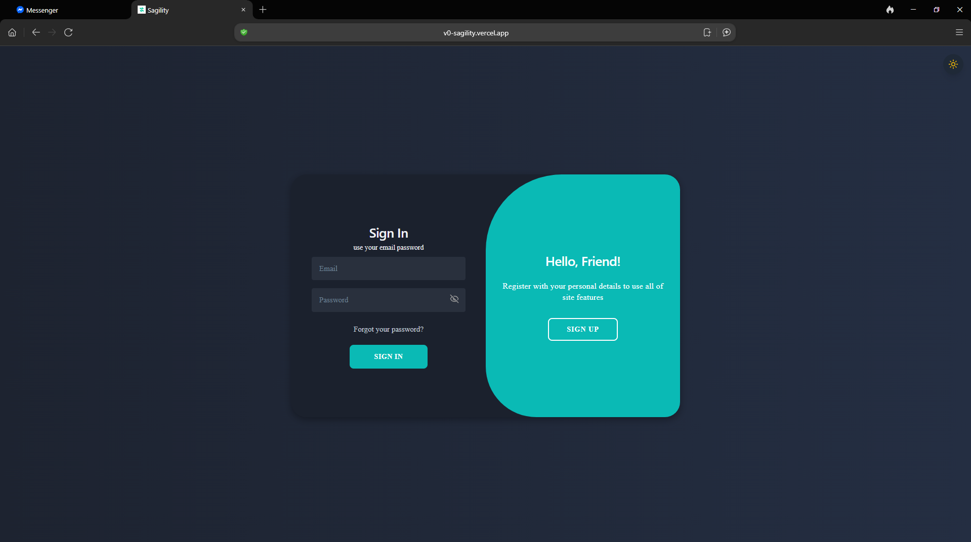
To sign in as an admin, another administrator must first grant you the admin role.

Admin Dashboard:
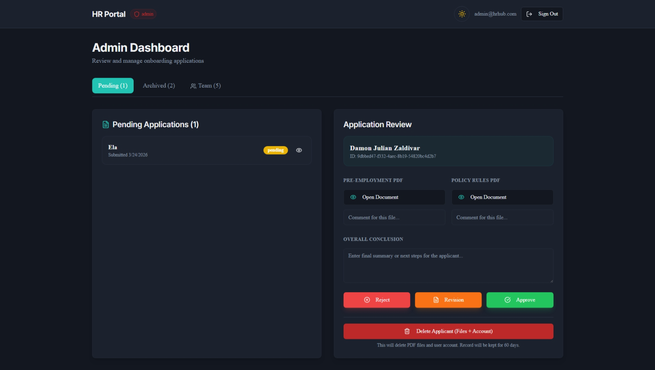
Use this page to manage incoming applications and take one of three actions:
- Approve: If all requirements are met.
- Request Revision: If updates or corrections are needed from the applicant.
- Reject: If the application fails to meet the requirements.
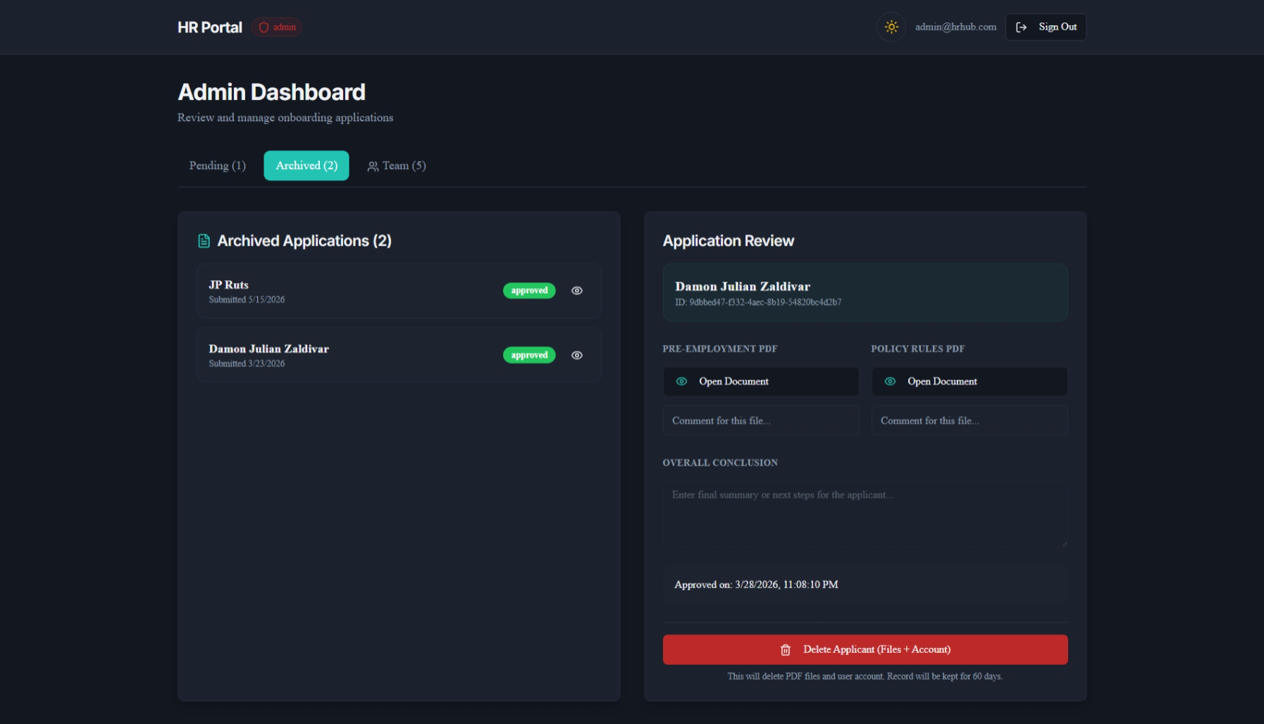
From this page, you can:
- View all approved applications.
- Delete applicant records and their submitted forms.

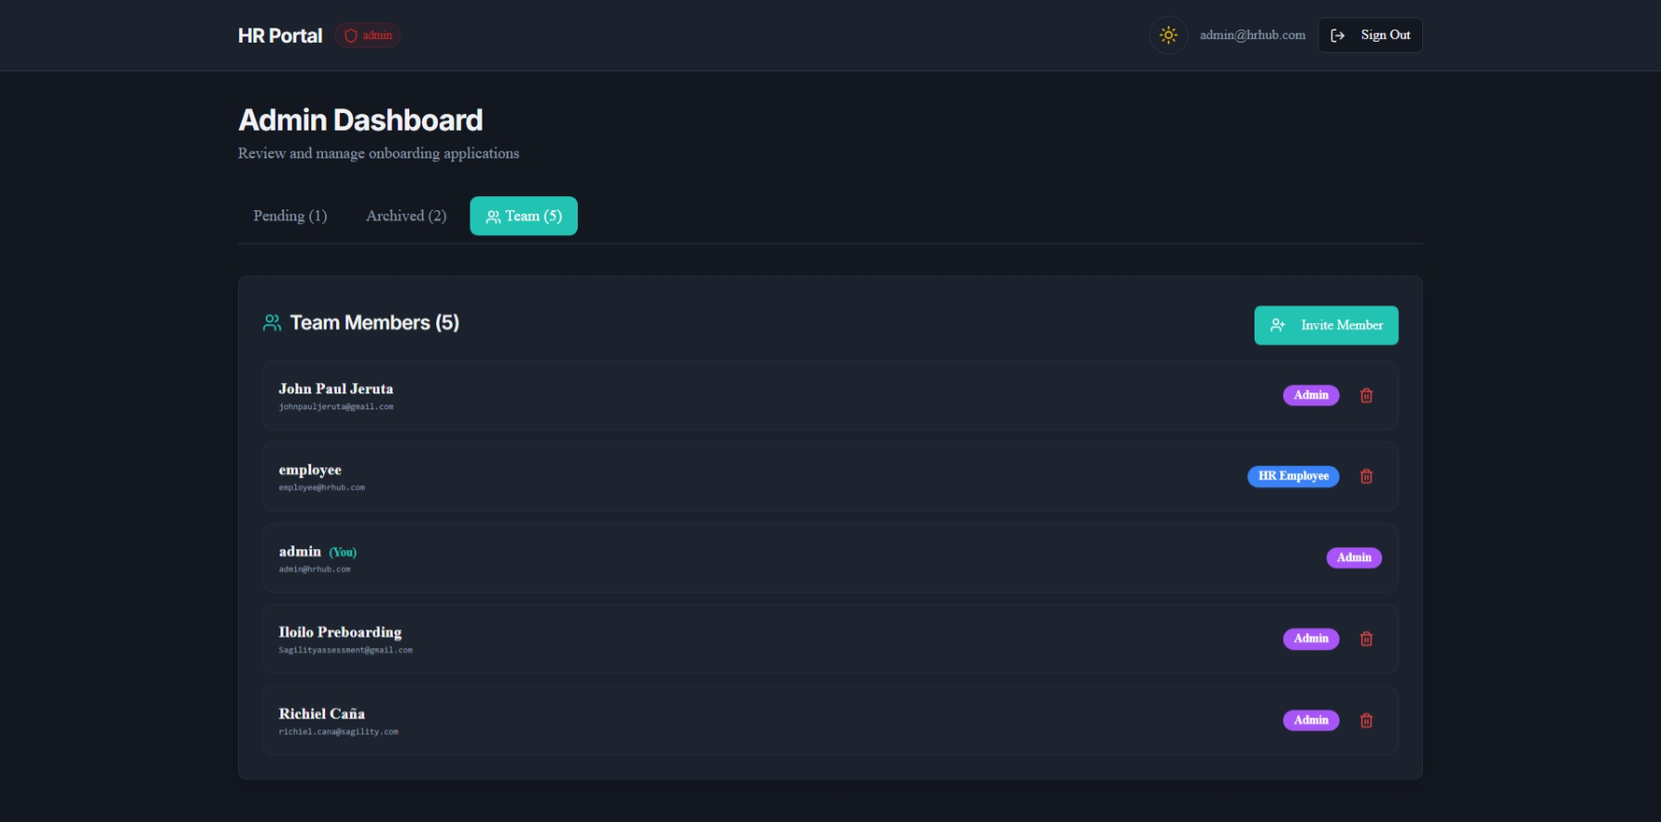
As an admin, you can use this page to:
- View existing members
- Invite new members
- Assign or change member roles
- Remove members from the system

